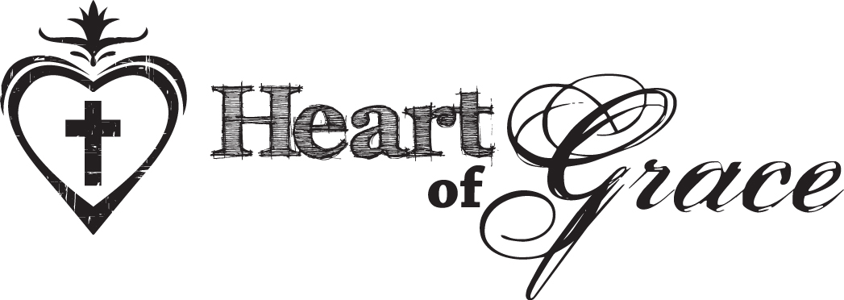
Message 8 – What Lies Ahead – 12/26/2009
Today we stand at the threshold of the unknown; before us lies a New Year. Who knows what lies ahead? What new experiences or changes will come our way? We definitely know what has happened in the past year. This may have been a very difficult year for you. You may have lost a precious loved one, you may have been very sick; you may have went through family struggles or financial difficulties.
There is no doubt that we live in a depressing time. The economy of our country is very unstable, and many families have lost their jobs, their homes, and other possessions. Drugs and alcohol abuse are at an all time high. Many lives have been lost this past year because of this abuse. Many children have been neglected and abused as a result of drug and alcohol abuse. Cancer has become a common illness. Most every family has had to deal with this illness in one way or another.
Although there is something about the start of a new year that brings hope or optimism, in reality all of the problems that we have faced this past year will be there in the coming year. The only real hope or change that anyone can depend on is the hope and peace that can be found in God and His son, Jesus Christ. Everything around us is subject to change, so our trust should not be placed in the hope that life will always be what we want it to be; even that it will remain without change.
The only real constant, the only true security lies only in God. It is entrusting Him with our lives and His will for our lives that will bring peace to our heart. God, having all knowledge, knows what is best for us because He alone sees the whole picture of our lives. And because He is a God of pure love, His will is to bless our lives with goodness. However, it is then that we must pause and acknowledge that only God knows what is good for us.
In our limited vision, we may feel that God’s will cannot surely be one of good will toward us because we often desire things to be different, and sometimes we cannot see the “good”. But we can rest assured that it is our to our good, even though we may not discern it as such, because He, our heavenly Father, can only act out of love, an enduring and unchanging love for His children. The greatest and most profound manifestation of His love toward us was giving His Son, Jesus, to die on the cross for our sin. Jesus, the perfect sacrifice, took our place and became the atonement for our sin, so that we could have eternal life.
Jesus loved us enough to give His life so that we could have life. It is in accepting Jesus as our Savior that the only true peace and security can be found. Jesus said that any that would come to Him that He would in no wise cast out or not save. He waits without wavering to welcome whosever will. Come and find peace and unchanging hope in Him today.
© 2009 The Heart of Grace Devotionals

